Program 1:

import java.io.\*;

import java.util.\*;

class vowels

{

public static void main(String args[])

{

try

{

int i,count=0;

Scanner sc=new Scanner(System.in);

System.out.println("Enter the String: ");

String str1=sc.nextLine();

String f=str1.toLowerCase();

char e[]=f.toCharArray();

for(i=0;i<str1.length();i++)

{

if(e[i]=='a'||e[i]=='e'||e[i]=='i'||e[i]=='o'||e[i]=='u')

{

count=count+1;

}

}

System.out.println("The number of vowels in the given string "+str1+" is "+count);

}

catch(Exception e)

{

System.out.println("Invalid");

}

}

}

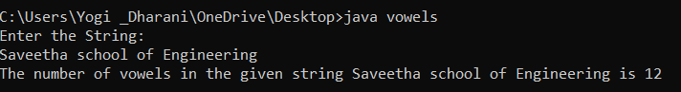

Program 2 :

import java.util.Scanner;

public class cons

{

public static void main(String [] args)

{

Scanner sc=new Scanner(System.in);

int vowles=0;

System.out.println("enter a sentence: ");

String str=sc.nextLine();

System.out.println("vowels are:");

for(int i=0;i<str.length();i++)

{

char ch=str.charAt(i);

if(ch=='a'||ch=='e'||ch=='i'||ch=='o'||ch=='u'||ch=='A'||ch=='E'||ch=='I'||ch=='O'||ch=='U'){

System.out.println(str.charAt(i));

}

}

System.out.println("Con are:");

for(int i=0;i<str.length();i++)

{

char ch = str.charAt(i);

if (ch == 'a' || ch == 'e' || ch == 'i' || ch == 'o' || ch == 'u' || ch == 'A' || ch == 'E' || ch == 'I' || ch == 'O' || ch == 'U') {

vowles++;

}

else {

System.out.println(str.charAt(i));

}

}

}

}

Output:

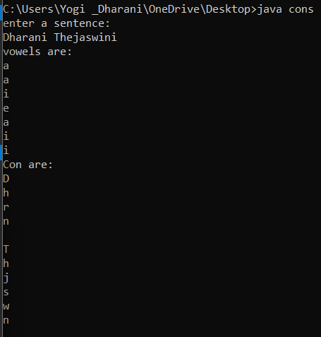

Program4:

import java.util.\*;

public class IteratorDemo

{

public static void main(String args[])

{

ArrayList al=new ArrayList();

al.add("C");

al.add("A");

al.add("E");

al.add("B");

al.add("D");

al.add("F");

System.out.println("Original contents of al:");

Iterator itr=al.iterator();

while(itr.hasNext()){

Object element=itr.next();

System.out.println(element+"");

}

System.out.println();

ListIterator litr=al.listIterator();

while(litr.hasNext()){

Object element=litr.next();

litr.set(element+"+");

}

System.out.println("Modified contents of al:");

itr=al.iterator();

while(itr.hasNext()){

Object element=itr.next();

System.out.println(element+"");

}

System.out.println();

System.out.println("Modified list backwards:");

while(litr.hasPrevious()){

Object element=litr.previous();

System.out.println(element+"");

}

System.out.println();

}

}

Output:

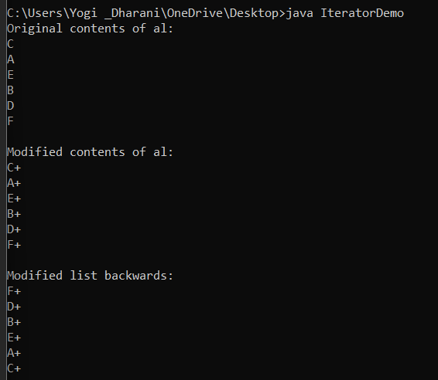

Program 6:

import java.io.\*;

import java.util.\*;

class tg<T>

{

T a;

T b;

tg(T a1,T b1)

{

a=a1;

b=b1;

}

void swap()

{

T c=a;

a=b;

b=c;

}

void print(){

System.out.println(a);

System.out.println(b);

}

}

class gdemo

{

public static void main(String args[])

{

tg<Integer>obj=new tg<Integer>(45,50);

System.out.println("Before swapping");

obj.print();

System.out.println("After swapping");

obj.swap();

obj.print();

tg<String>obj1=new tg<String>("SSE","VIT");

System.out.println("Before swapping");

obj1.print();

System.out.println("After swapping");

obj1.swap();

obj1.print();

}

}

Output:

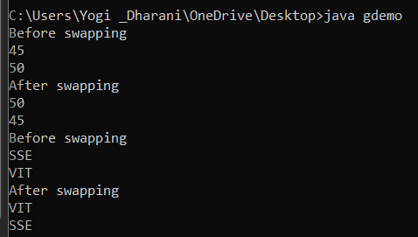

Program 8:

import java.io.\*;

import java.util.\*;

class Table

{

void printTable(int n)

{

synchronized(this)

{

for(int i=1;i<=5;i++)

{

System.out.println(+n+"\*"+i+"="+(n\*i));

try

{

Thread.sleep(500);

}

catch(Exception e)

{

System.out.println("INVALID");

}

}

}

}

}

class Mythread1 extends Thread

{

Table a;

Mythread1(Table a)

{

this.a=a;

}

public void run()

{

a.printTable(5);

}

}

class Mythread2 extends Thread

{

Table a;

Mythread2(Table a)

{

this.a=a;

}

public void run()

{

a.printTable(10);

}

}

class t

{public static void main(String args[])

{

Table obj=new Table();

Mythread1 th1=new Mythread1(obj);

Mythread2 th2=new Mythread2(obj);

th1.start();

th2.start();

}

}

Output:

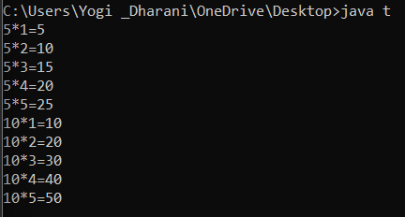

Program 5:

import java.io.\*;

import java.util.\*;

class d

{

public static void main(String args[])

{

int[] numbers = {1, 2, 3, 4, 5};

try {

int x = numbers[5];

System.out.println(x);

} catch (ArrayIndexOutOfBoundsException e) {

System.out.println("Error: Index is out of bounds.");

}

}

}

Output:

